General Studio Safety Rules and Procedures

Compliance with all applicable rules, regulations and procedures is mandatory for all students in the studio at all times to ensure a safe working environment for all. Safety is of utmost importance – please consider your safety as well as others.

Student Safety Contract
You must read through the following rules and regulations and complete the attached “Student Safety Contract” to acknowledge your understanding, as well as to ensure your adherence to all applicable safety standards.

Operator License
Additionally, you will be required to keep an accurate record of all tool specific training received in the studio. Only upon completion of applicable tool safety tests, and following the instructor orientation, will you be permitted to use specific tools in the studio.

Student Code of Conduct – Rights and Responsibilities
*Based on all applicable Federal, Provincial, Municipal and Industry (OH&S) Safety Standards

Employer (School and Instructor)

The employer (instructor) shall:
• provide a safe work environment through an established safety program, including all routines, operations and procedures.
• inform students of rights and responsibilities, and ensure compliance with all established routines, operations and procedures.
• exercise due diligence in deliverance of all training and instruction to students.

Employee (Student)

The employee (student) shall:
• inform instructor of all physical or mental disabilities, medical problems, allergies and/or conditions which may adversely affect studio performance.
• report all accidents, injuries, hazards and concerns immediately to instructor.
• notify instructor of any and all concerns regarding all required tool operation, maintenance, or repair.
• comply with all requisite classroom routines, safety requirements and operating procedures at all times.
• exercise due diligence in compliance with all verbal and written instructions regarding studio behaviour, accredited actions, expectations and requirements.

Failure to comply with any of the above may result in the suspension or removal of studio privileges

1. Instructor approval MUST be obtained prior to all machine operation. Ensure proper training and certification is complete. You may only use equipment for which you are certified. A list of your certifications is attached to the end of this document. If you are unsure about any operating procedure or task, you must request instructor assistance.

2. All unsafe or hazardous conditions, equipment malfunction, accidents and/or injuries (however slight) MUST be reported immediately to the instructor.

3. All required Personal Protective Equipment (PPE) MUST be worn at all times.
Cooperate and comply with all posted regulations and procedures to ensure a safe work environment for all. Caution anyone committing an unsafe act!

4. Safety guards on all machines MUST be in proper position when operating.

5. Appropriate clothing MUST be worn at all times in the studio. Remove or fasten any loose clothing, long hair or jewellery. No short pants, no sandals!

6. Focus on the task at hand; NEVER be a distraction or become distracted!
Obey all rules concerning operator safety zones.

7. Use the right tool for the right job; NEVER use tools other than for their intended purpose. Do not attempt shortcuts – use safe work practices!

8. Horseplay in the studio is strictly PROHIBITED! Throwing items or running in the studio will result in immediate suspension of studio privileges!

9. Housekeeping practices MUST be observed at all times to ensure a safe work environment for all. Keep floor and work surfaces free of scraps and litter, wipe up any spilled fluids and use proper disposal procedures. Ensure that tools and materials are always used and maintained in a safe manner.

10. Students MUST seek permission prior to access to all storage rooms.

The above ‘Rules and Regulations’ are established for the protection and safety of all students. Failure to adhere to any of the above may result in disciplinary measures including suspension or removal of studio privileges.

I have read and understand all the above rules and regulations. By signing below, I agree to adhere to all requirements, at all times, to the best of my ability. I acknowledge and accept responsibility for my behaviours, and will consciously assist others in fulfilling all studio requirements, expectations and obligations.

Date:

Student Signature:
Parent Signature: ________________________________
Teacher Signature:

This document must be kept in your class duotang and brought to every class.

CERTIFICATIONS

Approved | Date | Tool
 |  | Hand Tools (screwdrivers, hammers, pliers, snips, etc)
 |  | X-acto Knife / Rotary Cutter
 |  | Hot Glue Gun / Soldering Iron
 |  | Electric Hand Drill
 |  | Drill Press
 |  | Band Saw

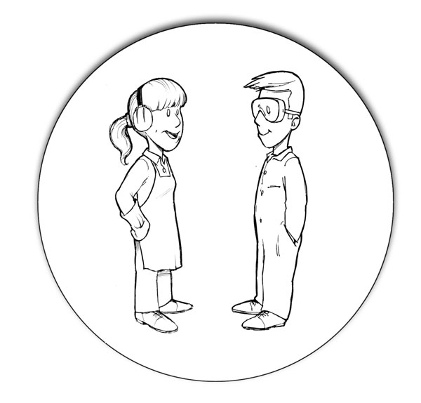
Information Sheet
WORKSHOP SAFETY

Topic Information
Accidents | Immediately report all accidents or injuries to your teacher so that proper treatment can be given and the dangers removed or dealt with.
Behaviour | Workshops are hazardous environments-adopt a calm, careful attitude at all times. Walk, don't run, avoid pushing, bumping or startling others, and don't throw things.
Clothing | Dressing appropriately for the job is a very important consideration when working in a shop area. Tuck in loose clothing, remove all jewelry and tie back long hair to prevent them from getting caught in machinery. Wear sturdy, protective shoes and use the protective gear provided, i.e., eye and hearing protection. Students wearing high heels or sandals will not be permitted in the shop.
Emergencies | Know what to do in an emergency! Be familiar with all emergency equipment in the shop, including fire extinguishers, power shut off buttons, fire blankets, first aid kits, and eye wash stations.
Eye protection | Eye protection must be worn if there is any chance of injury or irritation of the eye.
Housekeeping | Clutter and spills pose unnecessary hazards-tripping, slipping, bumping into things, dropping things off messy work surfaces-so keep the floor and work areas clear and clean, store your tools, materials and projects away safely and securely, and keep aisles and exits free of obstructions at all times.
Mental condition | Most accidents occur when people are tired, rushed or under the influence of alcohol or drugs, so think SAFETY. If you are tired, stop and rest. If you are rushed, slow down. If you are under the influence of alcohol or drugs-DO NOT WORK in the shop area.
Personal responsibilities | When working in a shop environment, be aware of the risks your work may pose to others, especially when using equipment such as arc welders, compressed air, and grinders. If you see something dangerous or consider your work environment to be unsafe, report it so that it can be fixed. If you feel unsafe about a particular activity, consult with your instructor before proceeding. Conduct regular safety checks on yourself, your material and your tool.
Working conditions | Set up your work area so that it is well-organized, well-lit, and adequately ventilated. To prevent unnecessary strain, make sure that you are in a comfortable working position.

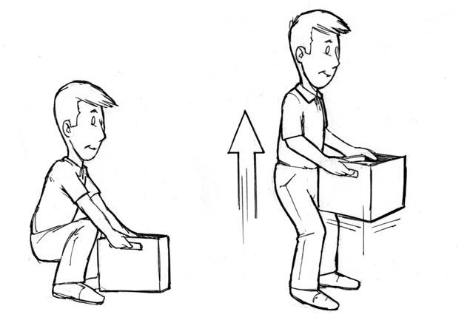
Information Sheet
TOOLS AND MATERIALS SAFETY

Topic Information
Compressed air | Occupational Health and Safety Regulation (WCB) states that compressed air should not be used to clean clothing, except in carefully controlled circumstances (e.g., where the pressure is limited to 10 psig), or for cleaning off equipment if someone could be exposed to the jet of air or to the material it expels. Use a vacuum cleaner to clean clothes and the shop area.
Condition of tools | Only use tools that are in good working order. If a tool is dull, broken or out of adjustment, give it to your instructor or ask for permission to fix it.
Material handling | Back injuries are common among people who work in shop areas, so handle large and/or heavy materials with care using proper lifting techniques. Also make sure that you don't run into other people when you are moving things, and ensure that all large and/or heavy objects are safely and securely stored. Ask for help if materials are heavy.
Protect your hands | Most accidents in school workshops involve students' hands. To prevent injuries, adhere to the following rules: a) keep your hands behind the blade when using a cutting tool, b) do not use your fingers to test tools for sharpness and c) place your hand near, but not on, an object when testing for heat.
Secure your work | If the object you are working on is stable, it is less likely to slip and cause an injury; so use the vice or clamp on your workbench to secure the object. Never hold stock with one hand while trying to cut, chisel or drill it with the other hand.
Sharp objects | Do not carry sharp objects such as nails, chisels, etc., in your pockets or your mouth! Carry them with the pointed end facing downward.
Use tools as intended | Using tools improperly can lead to frustration, injury of self or damage to the tool, e.g., hammering with a wrench, prying with a chisel, or using files without handles. Take the time to get the right tool for the job.

SAFE USE OF X-ACTO KNIVES AND ROTARY CUTTERS
- Plan before you cut! Draw a line (or mark the ends if using a straight-edge) before cutting.
- Blades should be retracted or covered when not actually cutting.
- Ensure your material is held securely on a flat cutting mat or board.
- Ensure there is no-one close enough to bump you or be cut if your knife slips
- Always move the knife away from your hand
- Pull the blade across the material being cut, move the material, then hold it tightly again, so that you are never cutting toward your fingers or any other part of yourself.
- Inform the teacher immediately if you do cut yourself (regardless of how bad the cut is).

Hands are the most vulnerable part of the body.
Eyes and ears also need protection.
Ask when you are not sure!
Dress safely using the appropriate protection.
Safety devices must always be used as intended.

POWER TOOLS SAFETY

Topic Information
Authorization | You must have authorization from your teacher before using any power tools.
Condition of tools | Only use tools that are in good operating condition. If anything seems wrong with a machine-unusual vibrations or noises-check it out before using the machine.
Personal protective equipment | Wear ear and eye protection when operating all power tools. Long hair must be contained before operating any power equipment.
Know how your machine works | Know which direction your tool will go when you run material through it, and which way the material will go. In other words, make sure you know what is going to happen before you operate a machine so that you can be ready to control those forces.
Lockout | When doing any maintenance work on a power tool, isolate the source of power (unplug it, switch the breaker off and follow written lockout procedures) to ensure that the machine does not start running when you are working on it.
Operator | The power tool operator must be qualified to use the tool. Each power tool is designed for only one operator. This person must always concentrate on the task at hand, so never distract, bump or rush them when they are using a machine-no horseplay!
Path of the tool | Whatever tool you are using, make sure it will cut, drill or grind only what you want to cut, drill or grind-you do not want the saw blade sticking out the bottom of the stock, the cutter hitting the top of a vice, or the drill bit breaking through the stock. Be aware of the cutting path of the tool-keep your hands away from this area. Make sure the cutting part is not going to come in contact with the power cord.
Power cord damage | Check all power cords daily for tears or cuts in the insulation, loose connections (plug to wire, wire to tool) and good ground connections.
Secure your work | When working with portable power tools, make sure the material stays in place-put stock in a vice, or clamp it to a workbench before approaching it with a power tool. While operating the tool, maintain a firm grip at all times.
Start-up | Check to ensure all guards and safety devices are in place and functioning properly. Make sure the power switch is in the off position before plugging in a portable power tool. Only the operator is to turn the tool on.
Stay beside running power tools | Do not walk away from a machine you have been using until it comes to a complete  stop-it takes only a few seconds for a power tool to 'wind down' after it has been shut off.
Stop to make adjustments | Always unplug or lockout the tool before making any adjustments or changing settings where there is danger of being injured in the event of start up of the tool.

Information Sheet
PORTABLE POWER TOOLS SAFETY

Topic Information
Damaged power cord | Do not use tools if the power cord is damaged. The insulation should be intact and without tears, the ground connection should be working if the tool is designed with a ground, and the connections plug to wire and wire to tool should be solid. Fix or replace damaged cords
Direction of the tool and material | Understand which way the action of the tool will push the material and the tool itself. Usually they try to go in opposite directions. Power planers push the stock away and the tool towards the operator. Belt sanders do the opposite. Right angle grinders depend on which part of the wheel you grind with. The point is to make sure you know what is going to happen and are ready to control those forces. Hold that tool with a firm grip.
Ear and eye protection | Many portable power tools run at very high speeds and scream in operation. Wear hearing protection if the tool is noisy or you have to raise your voice to speak to others. Wear eye protection when using portable power tools.
Path of the tool | Make sure the path of the tool is clear. Saw blades stick out the bottom of the stock. Will they cut anything unintentionally? Is the cutter on your router or power planer going to hit the top of the vice? When the drill bit breaks through, where is it going? Whatever tool you are using, make sure it will cut, drill or grind only what you want to cut, drill or grind! Make sure the cutting part is not going to come in contact with the power cord.
Power switch | Check that the power switch is in the off position before plugging in any portable power tool.
Secure your work | Large machines stay in place while the material moves. With portable machines, the tool moves and the material is supposed to stay in place-make sure it does! Put the stock in a vice, clamp it to a work bench or wedge it in a corner, but don't try to hold a small piece of material in one hand while you approach it with a power tool held in the other.
Unplug the tool | Unplug the tool whenever you are changing bits, replacing blades or fixing something on the tool. You could easily bump the trigger unintentionally while handling the tool.  Keep the plug within your sight and control so that it doesn't get inadvertently plugged in while you are working on the tool.

BAND SAW SAFETY

° | Set the upper guide and blade guard so they are just above the stock. This guards the blade and helps to keep the cut straight. The upper guide should be within 3mm of the wood.
° | While cutting, use a push stick and keep your fingers at least 5cm away from the blade at all times. You can't cut your fingers if you don't touch the blade!
° | Always feed the stock with light pressure and avoid excessive twisting of the blade. If you push too hard or twist too much, you will hear the saw slow down. This is your cue to lighten up. Too much pressure or twisting can break the blade. Use even less pressure as you near the end of a cut because the blade will come out the last millimetre or so.
° | If you have a number of cuts to make, plan your work so you can proceed in a sensible order. Never back out of long, curved cuts.
° | Use relief cuts on sharp corners. Thinner blades can cut sharper corners without relief cuts.
° | Round or irregular shaped wood presents special dangers because the force of the blade can twist it out of your control. Never cut round or odd shaped pieces unless you use a jig to stabilize them.
° | If the machine has a brake, use it to stop the blade after the power has been switched off; otherwise, stay with the machine until the blade stops moving. Recognize that a blade is sharp enough to cut even when it is not in motion.
° | If the blade breaks, turn off the machine and tell your teacher.
° | Do not stand to the right of the band saw while someone else is using it. If the blade breaks, it might flip out in that direction.
° | Both eye and hearing protection are required when using a band saw.

ELECTRIC HAND DRILL SAFETY

° | Secure your stock before drilling. Large pieces may be stable on their own, but smaller pieces should be held in a vice. If there is any chance that the stock could catch on the bit and spin around, secure it in a vice or clamp. Keep the cord away from the drilling area.
° | Centre punch metals before drilling. Many of you have had the experience of trying to use a hand drill on a piece of metal only to find the bit scooting all over the surface. A small dimple made with a punch will keep the bit in place.
° | Make sure the bit is properly sharpened, and straight and tight in the chuck.
° | Tie long hair back-otherwise power equipment must not be used. Bending over your work or lifting the drill in the air are perfect opportunities for the electric hand drill to grab a strand or two.
° | Large drills are powerful enough to break your arm, so make sure you have a good grip on the drill and be prepared to hold it if it 'kicks,' especially as the bit passes through the far side of a piece of metal.
° | Both eye and hearing protection are required when using an electric hand drill.

DRILL PRESS SAFETY

° | Tie long hair back.
° | Remove all strings and/or jewelry that could get caught in the drill press.
° | The material you intend to drill must be held in the drill vice or be clamped to the drill table. This will prevent it from spinning around and hurting you if the drill bit were to catch as it went through.
° | Be sure to 'centre punch' hard materials like metals before you drill them. The punch mark will prevent the drill bit from slipping around as you try to start the hole.
° | Set appropriate drill speed for the drill bit.
° | Make sure the chuck key is out of the chuck every time you go to start the drill.
° | If you are drilling a series of holes or are in a rush to get onto the next job, slow down to make sure the bit is clear of the stock before you move it. If you do move the stock when the bit is still in the hole, you could break the bit.
° | Set up your operation to avoid drilling into the vice or table. Put some scrap wood under your work, or position it in the vice so that the bit will come through in the centre or at the side of the vice.

